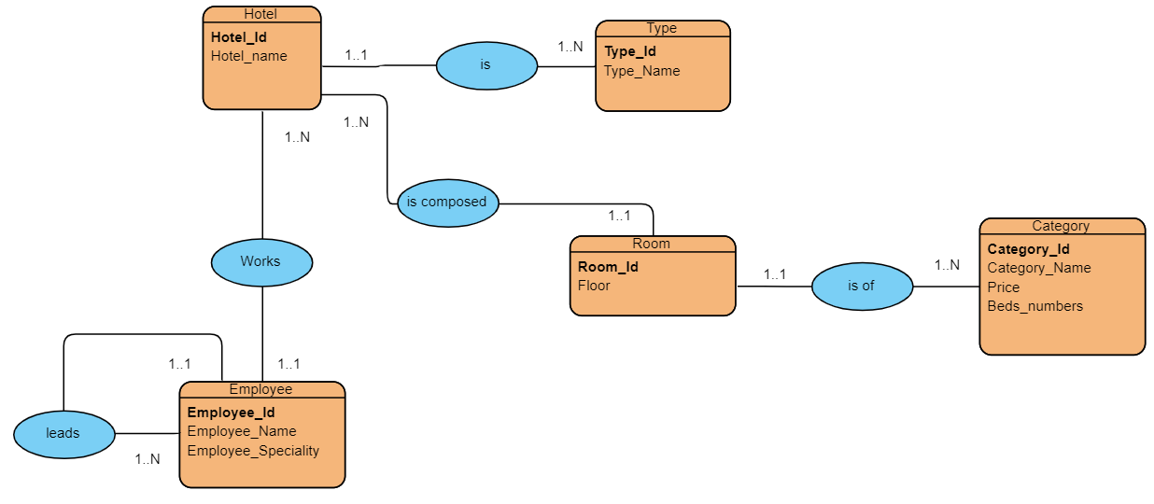**Entity Relationship model**

**Relational Diagram**

**Employee (Employee_Id,** Employee_Name, Employee_Speciality,#Hotel_Id,#DirectorId**)**;

**Departements (Hotel_Id,** Hotel_name,#Type_Id**)**;

**Type (Type_Id,** Type_Name**)**;

**Room (Room_Id,** Floor,#Hotel_Id,#Category**)**;

**Category (Category_Id,** Category_Name, Piece,Beds_Numbers**)**;